Supplemental Information for
Evaluating the effects of synthetic POM cycles and NAD kinase expression on fatty alcohol production in Saccharomyces cerevisiae
Bonnie A. McNeil¹, Charfeddine Khalifa¹, Anagha Krishnan², David T. Stuart¹³
Table S1 – S2
Figure S1 – S8
Current Affiliations
¹ Department of Biochemistry, University of Alberta, Edmonton, Alberta, Canada
² Department of Chemical and Biological Engineering, Colorado School of Mines, Golden, Colorado, USA
Bonnie A. McNeil email: bamcneil@ualberta.ca
Anagha Krishnan email: anagha1@ualberta.ca
David T. Stuart email: dtstuart@ualberta.ca

³ Corresponding Author
David T. Stuart
561 Medical Sciences Building
Department of Biochemistry
University of Alberta
Edmonton, Alberta, Canada
T6J 2H7
dtstuart@ualberta.ca

Table S1. Oligonucleotide sequences used for plasmid construction
Name | Sequence | Use
5’-HXT-V5 | CCTGCAGGTCGACTCTAGAGCCACTACTTCTCGTAGCAAC | Amplify pHXT7
HXTa3rs | CTCCCGGGATATCCTAGGTTGTTTTTGATTAAAATTAAAAAAACTTTTT | Amplify pHXT7
FBAa5rs | CAACCTAGGATATCCCGGGAGTTGATGGATCCAACTGGC | Amplify pFBA1
FBAa3 | TTTGAATATGTATTACTTGGTTATG | Amplify pFBA1
P3-O3 | TAACCAAGTAATACATATTCAAAATGTGGCCTATTCAGCAATCGCG | Amplify sMAE1
3’-MAE1noter | CCAGTGAATTCGAGTCTCGGTACCCCTACAATTGGTTGGTGTGCA | Amplify sMAE1
HXT*-P1 | AAAGTTTTTTTAATTTTAATCAAAAACAACATGTCGCAAAGAAAATTCGCC | Amplify PYC1 +250ds
PYC1-3 | AAGATGTTTCGCTAAAAGATGC | Amplify PYC1 +250ds
HXT*-P2 | AAAGTTTTTTTAATTTTAATCAAAAACAACATGAGCAGTAGTCAAGAAATTGG | Amplify PYC2  +250ds
PYC2-3 | TAAATAGAGTAGTTAACGTACTTG | Amplify PYC2  +250ds
O1-P2 | CATCTTTTAGCGAAACATCTTATCACACCCAATCCCCCAC | Amplify TEF1p
O4-P2 | AGTACGTTAACTACTCTATTTAATCACACCCAATCCCCCAC | Amplify TEF1p
TEFa3 | TTTGTAATTAAAACTTAGATTAGATT | Amplify TEF1p
P2-O2 | TCTAATCTAAGTTTTAATTACAAAATGTCGTTAAAAATTGCCATTT | Amplify ‘MDH2+250ds
Mdh2-F1 | GCCAGTTCCATCCATCAACTCCCAGTAAAGAGTTGTACATCAGGT | Amplify ‘MDH2+250ds
P2-O5 | TCTAATCTAAGTTTTAATTACAAAATGTATAAAGTGACTGTTTTGG | Amplify ‘MDH1+250ds
Mdh1-F1 | GCCAGTTGGATCCATCAACTCCCAATCATTTTTGTTTTTCCTCGTC | Amplify ‘MDH1+250ds
MAE-C5 | AATTGTCGCCACTAAGAGAGG | Amplify C-term of MAE1
MAE-C3 | GCGAAATAGATTATAATGCCTACAATTGGTTGGTGTGCAC | Amplify C-term of MAE1
CDCt5 | GTGCACACCAACCAATTGTAGGCATTATAATGTATTTCGC | Amplify CDC28 terminator
CDCt3 | GGTGAGCGAATTCTTCATTTTCTTTGATAATACGACC | Amplify CDC28 terminator
SalI-FBA1p | CCCGGTCGACAGTTGATGGATCCAACTG | Used with MAE-C3 to amplify FBA1p-MAE
5VH HXT7 | GCATGCCTGCAGGTCGACTCTAGAGGATCCCCACTACTTCTCGTAGGAAC | Used to clone single enzyme controls with and without myc tag
3 PYC1 MYC | CAATCTTCTTCAGAAATCAATTTTTGTTCTGCCTTAGTTTCAACAGGAACTTGG
5 MYC PYC1 TER | GAACAAAAATTGATTTCTGAAGAAGATTTGTGAACCGGTTAGTTCTCATTTATAATG
3VH PYC1 TER | CGACGGCCAGTGAATTCGAGCTCGGTACCCAAGATGTTTCGCTAAAAGATGC
3 PYC2-MYC | CAATCTTCTTCAGAAATCAATTTTTGTTCCTTTTTTTGGGATGGGGGTAG
5 MYC PYC2TER | GAACAAAAATTGATTTCTGAAGAAGATTTGTAATTTTTACTCGTTAATTATATTTTATGA
3VH PYC2 TER | CGACGGCCAGTGAATTCGAGCTCGGTACCCTAAATAGAGTAGTTAACGTACTTG
5VH TEF1 | GCATGCCTGCAGGTCGACTCTAGAGGATCCATCACACCCAATCCCCCAC
3 MDH1-MYC | CAAATCTTCTTCAGAAATCAATTTTTGTTCTTTACTAGCAACAAAGTTGACACC
3VH MDH1 ter | CGACGGCCAGTGAATTCGAGCTCGGTACCCTCATTTTTGTTTTTCCTCGTCTACG
3 MDH2 MYC NEW | CAAATCTTCTTCAGAAATCAATTTTTGTTCAGATGATGCAGATCTCGATGC
5 MYC MDH2TER | GAACAAAAATTGATTTCTGAAGAAGATTTGTAATGAGCATCGGACCGAAGCA
3VH MDH2TER | CGACGGCCAGTGAATTCGAGCTCGGTACCCAGTAAAGAGTTGTACATCAGGTAAG
UTR1 5 NEW | GCGTCTAGAAAAAAAATGAAGGAGAATGACATGAAT | Used to clone NAD Kinases
UTR1 3 | CCGCAACTGCAGAAGCACTAGTAATTACCTACTTGAAAAAAGCC | Used to clone NAD Kinases
YEF1 5 | GCGTCATCTAGAAAAAAAATGAAAACTGATAGATTAC | Used to clone NAD Kinases
YEF1 3 NEW | TCCCTGCAGGCACTAGTAACCTTATCATATGGTTAA | Used to clone NAD Kinases
POS5C 5 NEW | CGCCCTAGGAAAAAAATGAGTACGTTGGATTCACATTC | Used to clone NAD Kinases
3’ POS5 | ATACTGCAGACTAGTCTTCTTGTTAGGCATGTCTTCCC | Used to clone NAD Kinases

Table S2. Oligonucleotides utilized in qPCR
Name | Sequence
PYC1 F1 | GGT GTC AAG ACC AAC ATT CCC TTC C
PYC1 R1 | CAT TGC CCT GAG CAT CGT GC
PYC1 F2 | TTT CGA GGC TGA CTT GAA GGG C
PYC1 R2 | AAA TTG TGC CAG ATC ACC AAC GAC C
PYC2 F1 | GCT ACT ACT CTC GCC TCA CTA CG
PYC2 R1 | AAC CGT TAA CTG CCA AGT CTG CC
PYC2 F2 | CGT GAA TTA GAT GCA TAC TGG GCC G
PYC2 R2 | CAAAAAAGTCCATAACAGAGTCAGGAAAGTCC
MDH1 F1 | CAA AGA ATG GTG CTG GCT CTG CTA CG
MDH1 R1 | ATG GAT CTT TTC AAT ACC ATC TGG GCC
MDH2 F1 | TGT AAT TGG CGG GCA TTC TGG C
MDH2 R1 | TTC CAT GGA TCT GCT CAA TGT TAC CC

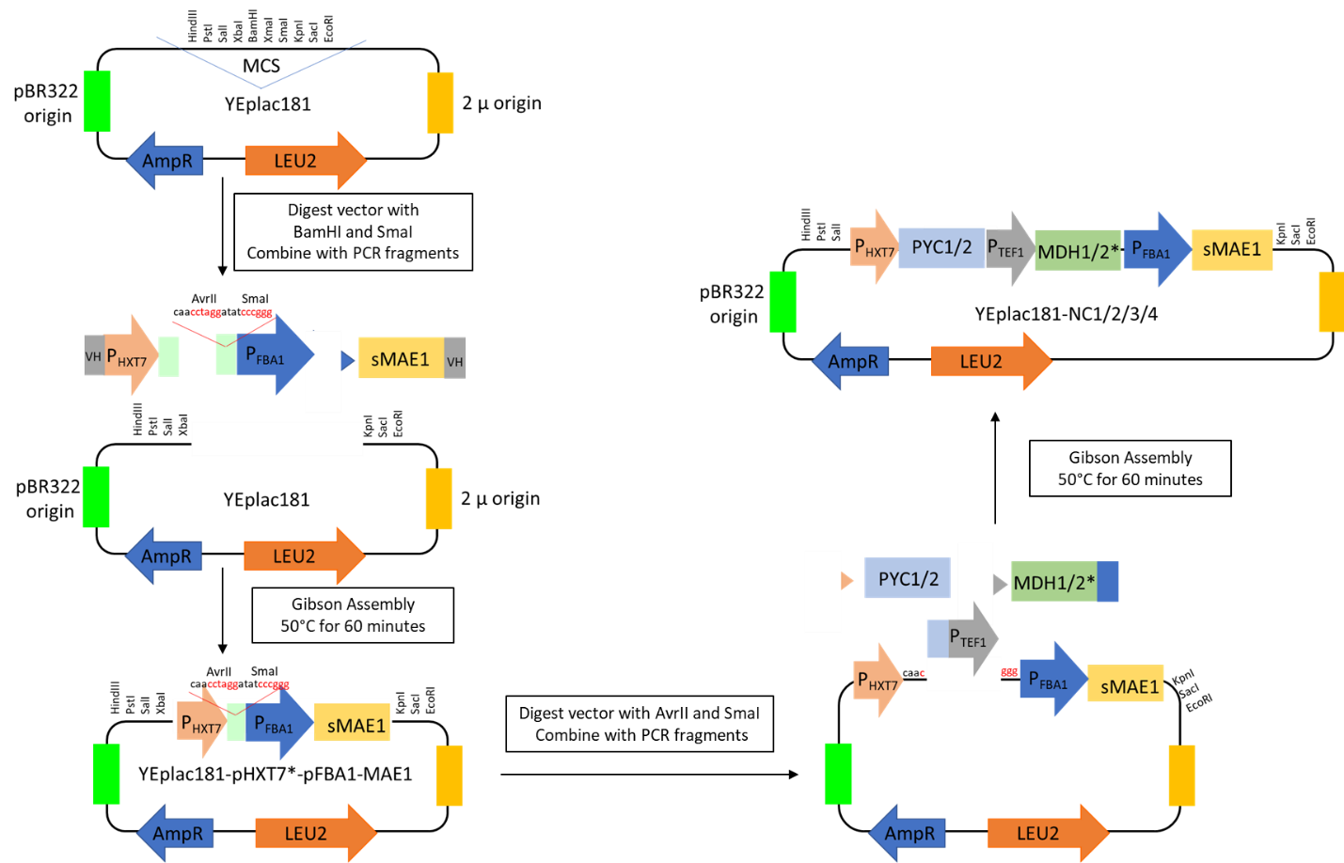

Figure S1. Schematic representation of the initial construction of the transhydrogenase-like shunts in the episomal vector, YEplac181

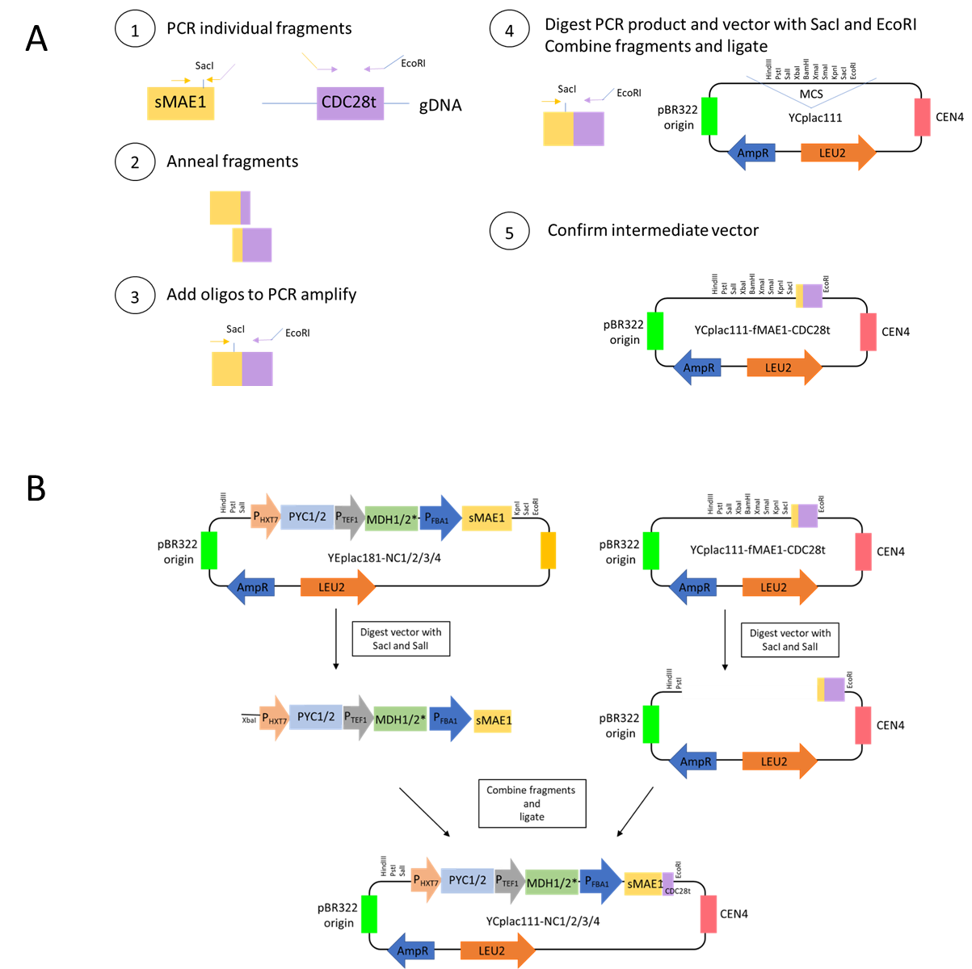
Figure S2. Schematic representation of the transfer of the transhydrogenase-like shunts to the centromeric vector, YCplac111. (A) The construction of the intermediate vector and (B) the transfer of the cassettes to create the final versions

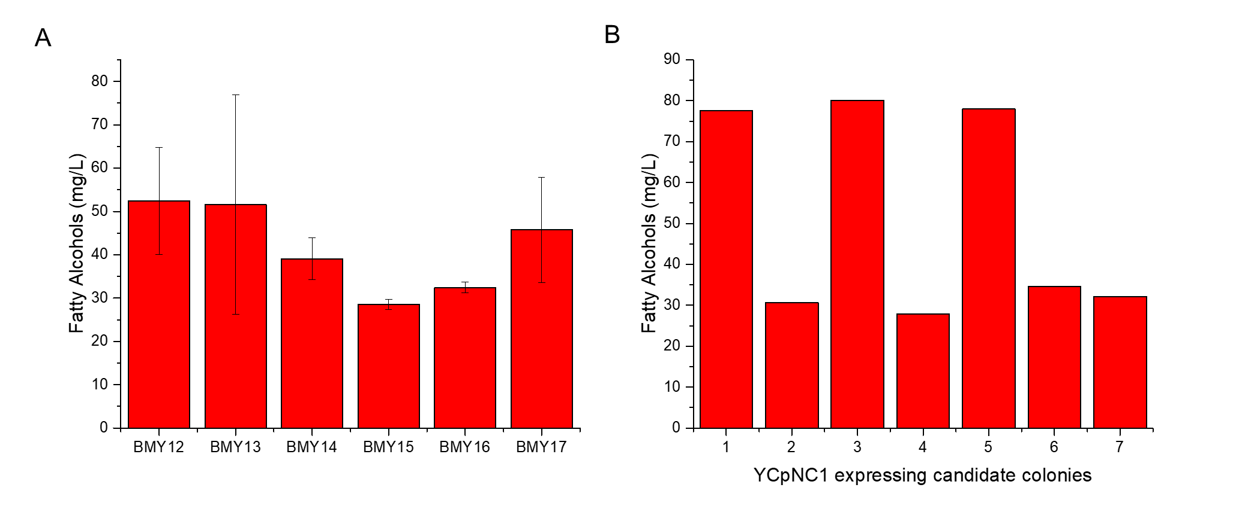
Figure S3. Production of Fatty Alcohols by initial candidate colonies of FAS overexpressing strains containing Synthetic POM Cycles. Average production from 7 independent candidate colonies of each strain are shown with standard deviation (A) and the individual production of the candidate colonies of BMY13 are shown in (B).

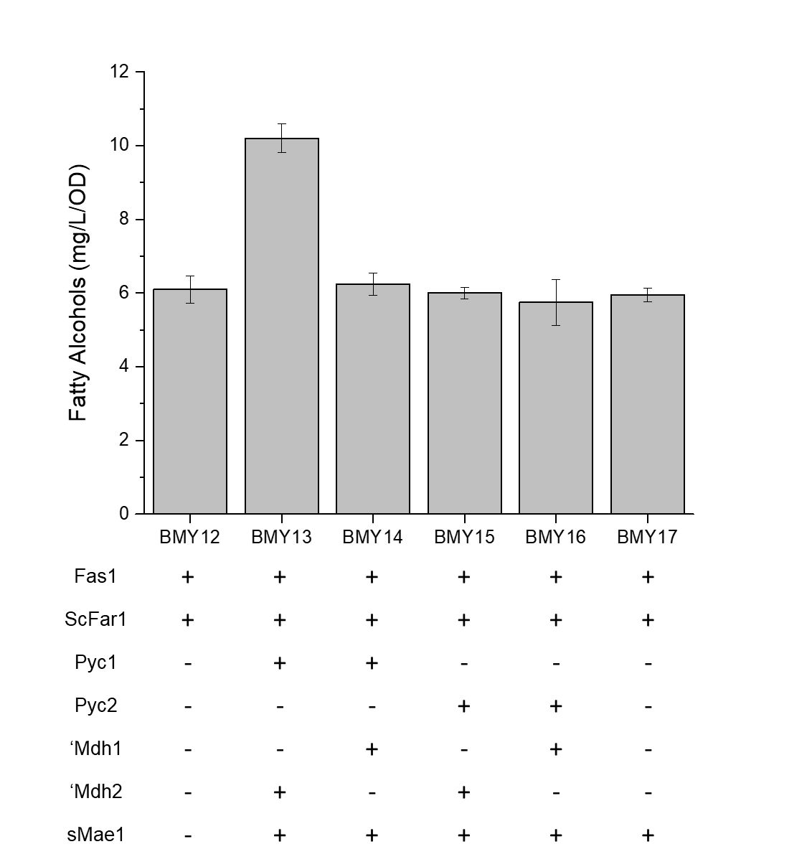
Figure S4. The effect of synthetic POM cycles on fatty alcohol production in FAS overexpressing strains. High producing colonies of strains BMY12-BMY17 expressed as mg/L/OD (n=3) Error displayed as standard deviation.

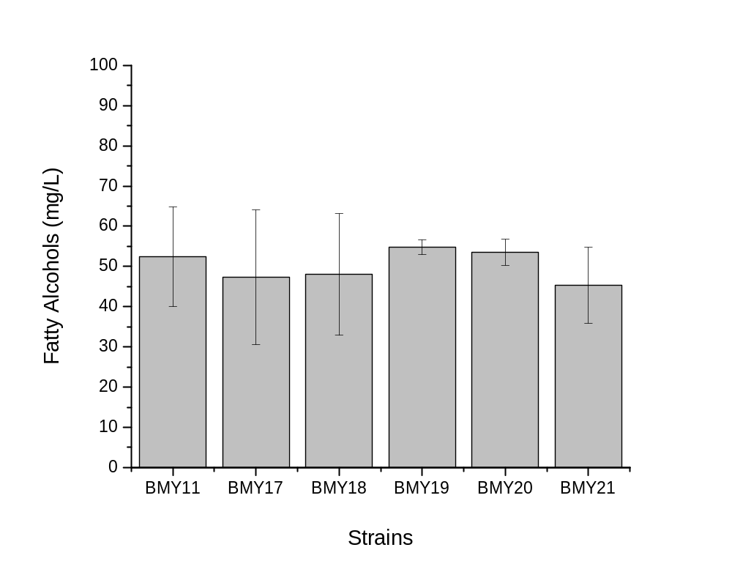

Figure S5. The effect of overexpression of the individual enzymes Pyc1, Pyc2, ‘Mdh1, ‘Mdh2 and sMae1 on fatty alcohol production. (n=3) Error displayed as standard deviation.

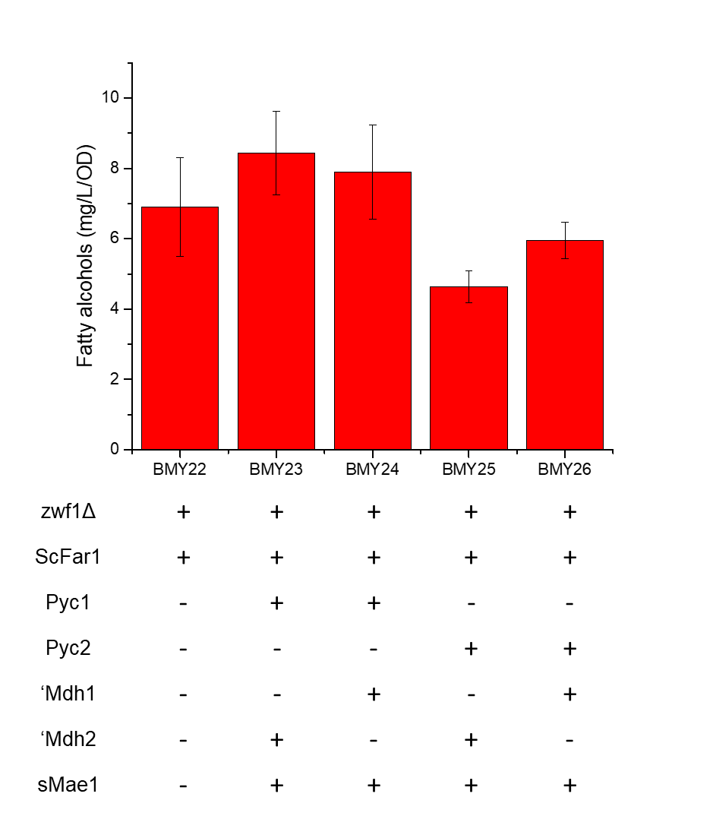
Figure S6. The effect of synthetic POM cycles on fatty alcohol production in zwf1Δ strains. High producing colonies of strains BMY12-BMY17 expressed as mg/L/OD (n=3) Error displayed as standard deviation.

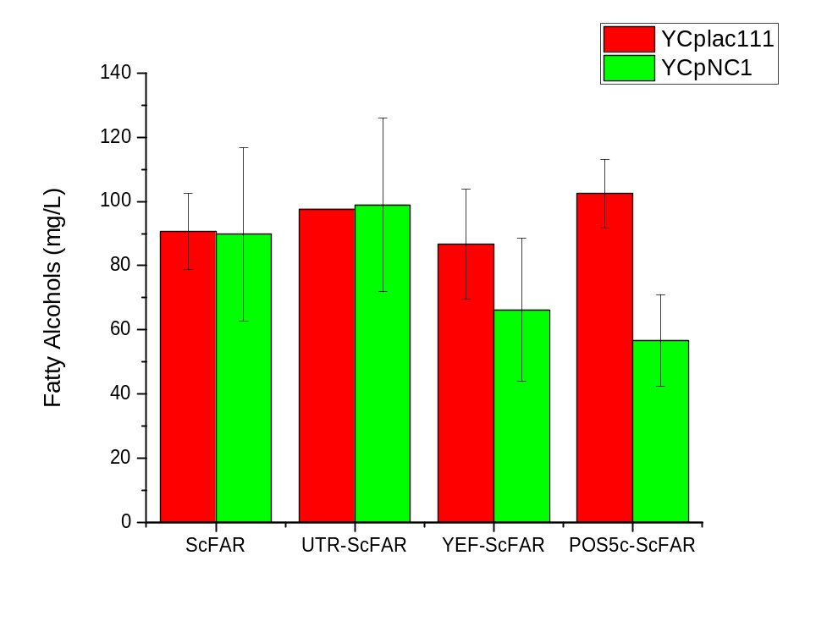
Figure S7. Production of Fatty Alcohols by initial candidate colonies of FAS overexpressing strains overexpressing NAD Kinases. Average production from 3 independent candidate colonies of each strain are shown with standard deviation either on their own or in conjunction with expression of the best synthetic POM cycle.

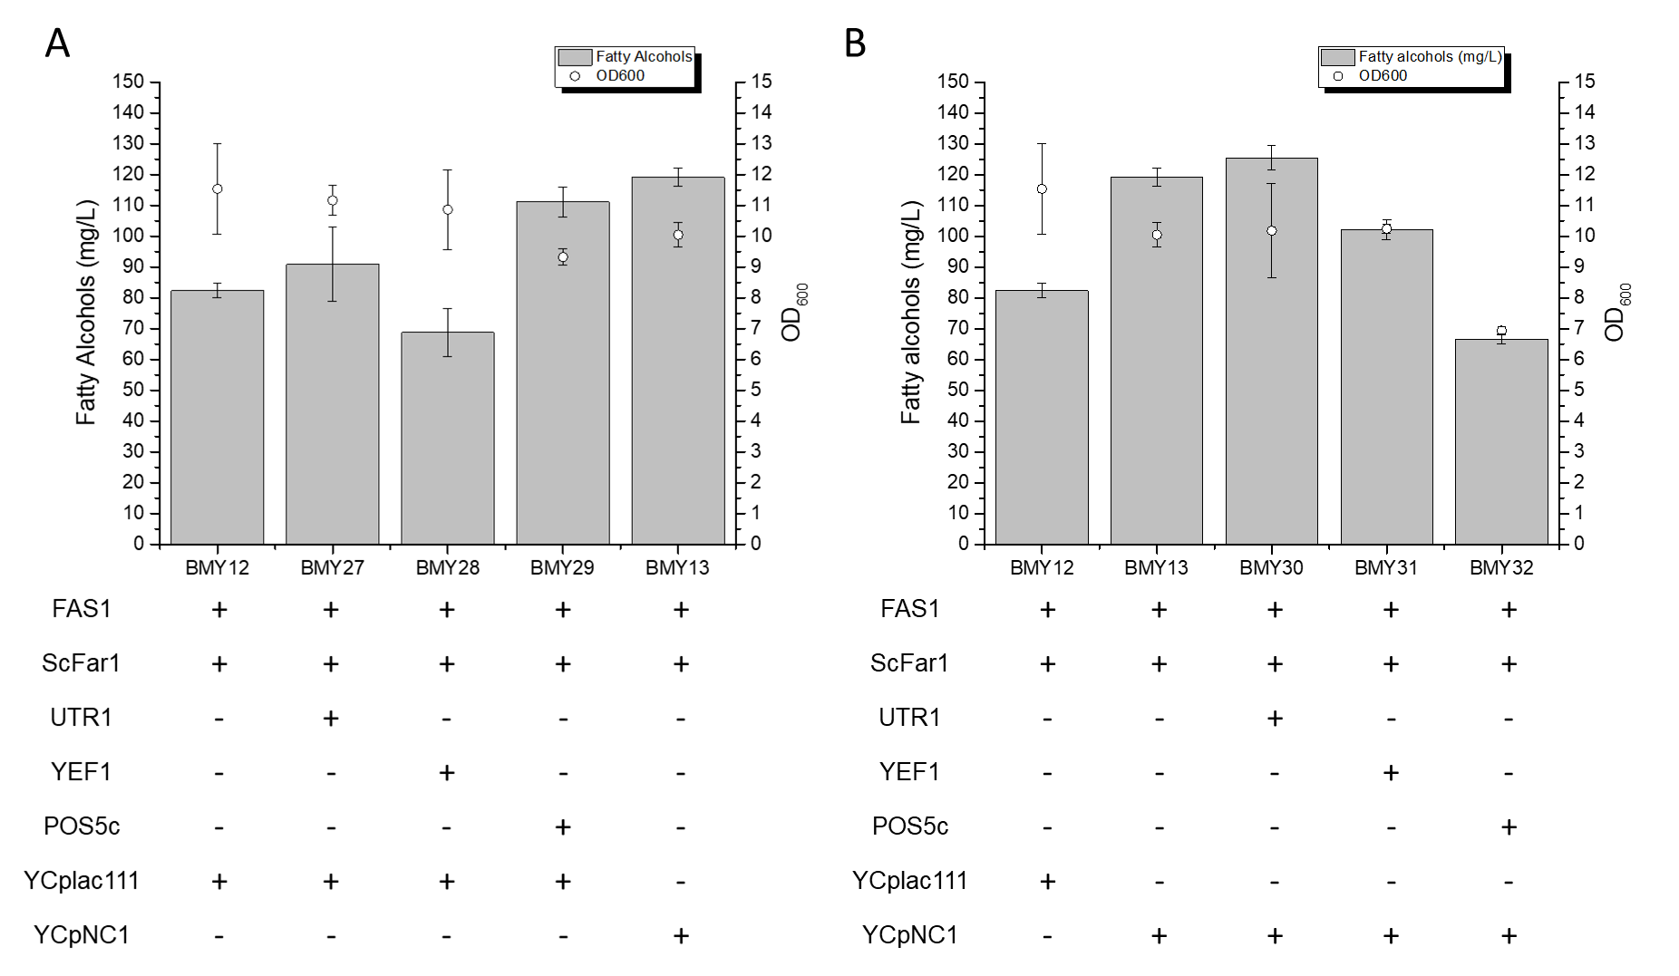
Figure S8. Effects of NAD Kinase expression and the synthetic POM cycle YCpNC1 (PYC1, ‘MDH2, and sMAE1) in FAS overexpressing, fatty alcohol producing strains for the high producing candidates. Comparison of NAD Kinase overexpression to YCpNC1 is shown in (A) while the expression of each of the NAD Kinases in conjunction with YCpNC1 is shown in (B). Shaded bars indicate mean fatty alcohol titers; open circles indicate mean cell density (OD₆₀₀) after 72 hours of shake flask culture. Error bars indicate standard deviation.

